**AQUA VITAE PARALLAX TRAILER.**

Shot Breakdown:

**I: EXT/ HIMALAYAN MOUNTAIN RANGE/ MIDDAY.**

1. **EXTREME WIDE SHOT:** Mountain range (Himalayas) in the background. Bright sunlight. Around noontime.

**CUT TO:**

1. **ZOOM IN:** Fast zoom in toward the mountain range and stop to frame the highest peak in a CLOSE UP.

**CUT TO:**

1. **WIDE SHOT**: A few mountain peaks are framed in this wide shot. Hold the frame as the sun travels from the cloudless sky to hide behind one of the mountain peaks. The light changes from bright to dim as the sun moves across the sky to behind the mountain.

**CUT TO:**

1. **LONG SHOT:** TRACK DOWN from the sky onto a snow covered mountain ledge. The figure of a man, legs folded and praying can be seen on this ledge. Hold the frame as he stands up. He has a grey-blue shawl draped across his shoulders. Continue to hold frame as the shawl slowly falls off him. He walks out of frame as the shawl flutters onto the ledge.

**CUT TO:**

1. **WIDE SHOT:** A larger framing without the man. More of the mountain in the background. Different *angle* from the previous shot. The shawl continues to flutter on the mountain ledge. A slowly building RUMBLING begins as an avalanche takes place.

**II: EXT/ HIMALAYAN MOUNTAIN RANGE/ MIDDAY- FLASHFORWARD.**

TITLE: ***MODERN DAY.***

1. **EXTREME WIDE SHOT:** Frame a large portion of a steep side of a mountain. Snow covers much of the mountain and falls lightly on the group. The light is cloudy and gloomy. A group of five people (mixed gendered) are dressed warmly in contemporary clothes suitable for climbing. They carry the necessary mountain gear. They are making their way up the mountain.

**CUT TO:**

1. **WIDE SHOT:** This shot only frames the group of climbers. The climber at the top trips and begins to fall. All the climbers below him/ her also begin to fall as a result. Track the falling climbers, i.e. move with them to keep them in frame.

**CUT TO:**

1. **WIDE SHOT:** One male climber falls on a mountain ledge (same as in the previous scene). The ledge is heavily covered in snow. The man is partially buried in snow.

**CUT TO:**

1. **LONG SHOT:** The man carefully stands up and shakes off the snow that’s clinging to his body and head.

**CUT TO:**

1. **WIDE SHOT:** The same framing as shot 3.Suddenly the sun comes out from behind the clouds and the light in the shot brightens.

**CUT TO:**

1. **LONG SHOT:** The man pats himself to check for injuries. He starts to walk away.

**CUT TO:**

1. **CLOSE UP:** This shot is a CLOSE UP of the man’s foot as it slips on the snow covered floor.

**CUT TO:**

1. **WIDE SHOT:** Same framing as shot 3 and 5. The man is slipping and sliding across the mountain floor. The begins to fall across the ledge but is saved when his foot gets caught on the shawl that lays fluttering on the edge of the ledge.

**CUT TO:**

**III: INT/ PRAYER HALL/ DAY.**

1. **WIDE SHOT:** Static Shot. A congregation of men and women are standing in a prayer hall. The place is filled with loud voices as a mixture of loud chants and shouting fills the hall.

**CUT TO:**

1. **MID SHOT:** The frame is panned across the eager faces of the men and women in this crowd.

**CUT TO:**

1. **LONG SHOT:** Static shot. This frame shows the stage that faces the crowd. A preacher stands still next to the Climber who escaped the avalanche. Hold the frame as the two men step aside to show, behind them, a glass case set on the stage. The grey-blue shawl is placed in this glass case.

**CUT TO:**

1. **WIDE SHOT:** Same framing as shot 1. The crowd begins to start shouting even louder- “Faith Bonds” and “Let’s Get the Holy Water.”

**CUT TO:**

**IV: EXT/ NHAVA SHEVA PORT/ DAY.**

1. **EXTREME WIDE SHOT:** A long line of truck are being driven across the piers along the port. On either side of the port are two groups, both comprised of large crowds of people. A lot of noise is created as both groups are shouting slogans. One group of people are wearing garments that denote them as Muslims. The other group are wearing clothes that denote them as Christians.

**CUT TO:**

1. **WIDE SHOT:** Hold the frame on the people dressed like Muslims. They’re chanting and shouting.

**CUT TO:**

1. **WIDE SHOT:** Hold the frame on the group of people dressed like Christians. They also chant and protest.

**CUT TO:**

1. **EXTREME WIDE SHOT:** Same framing as shot one. The two separate groups surge forward and begin attacking each other. Each group screams “God is Great” in different languages.

**CUT TO:**

1. **MID SHOT:** The frame pans across the crowd fighting each other.

**CUT TO:**

1. **WIDE SHOT:** In the background, far away from the fighting crowd, the police force is shown. They don’t interfere.

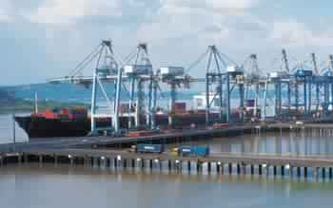

Nhava Sheva Port

**Glossary of terms:**

* **Extreme Wide Shot:** This is when the framing shows a large portion of the landscape/ scenery. Any human beings or animals are smaller in comparison to the scenery.

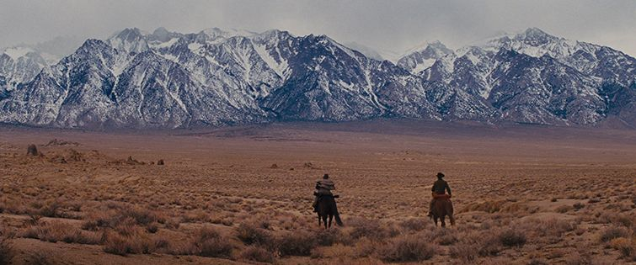

* **Wide shot:** Smaller than the previous framing size. The human/animal subjects are larger in the frame.

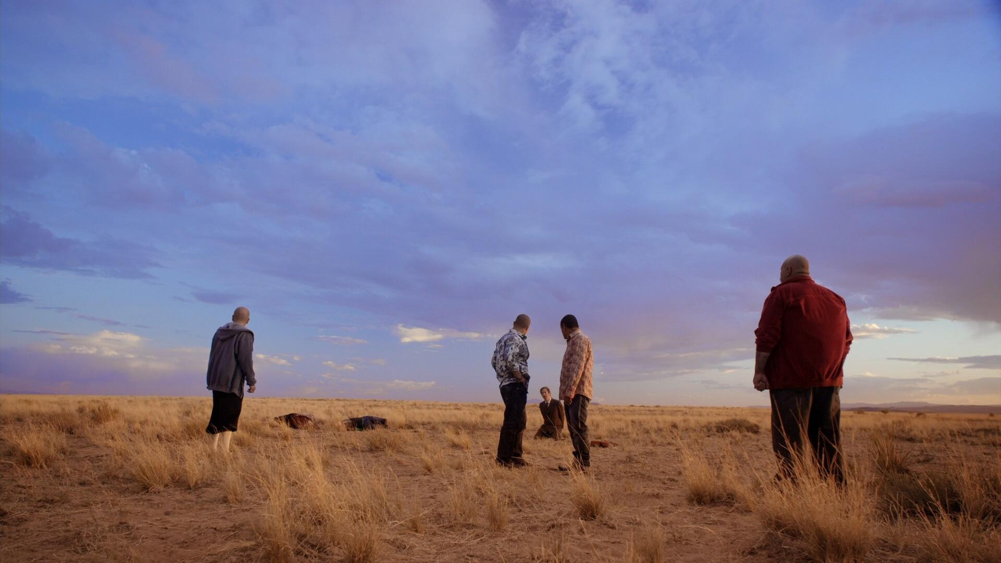

* **Long shot:** The full head to toe figure of the human being is in frame. Not much of the surrounding is visible.

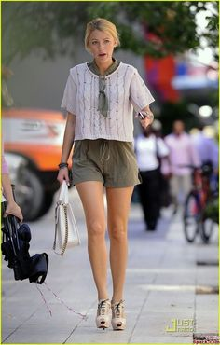

* **Mid Shot:** A person is in the frame only up to their shoulders.

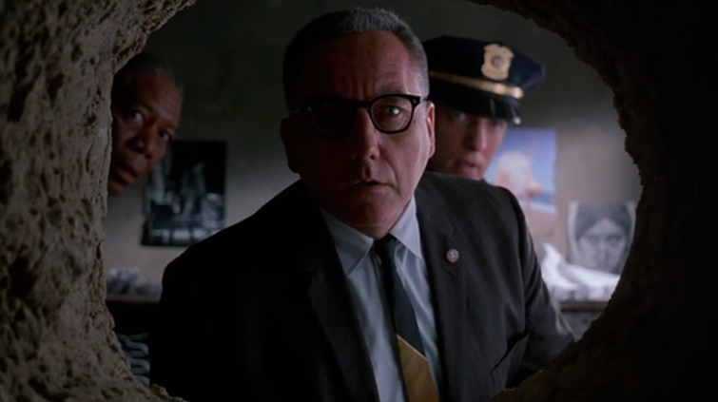

* **Close up Shot:** Shows only the required feature/ object.

